Israt Tasnim Esha received her B.Sc. Eng. in Computer Science and Engineering from Khulna University of Engineering & Technology (KUET), Khulna, Bangladesh, in 2025. She is currently a Lecturer in the Department of Computer Science and Engineering at the University of Brahmanbaria (UoB). Her research interests include Machine Learning, Artificial Intelligence, Information Security, Blockchain, Federated Learning, and Software Engineering. She can be reached at israttasnimesha1046@gmail.com.
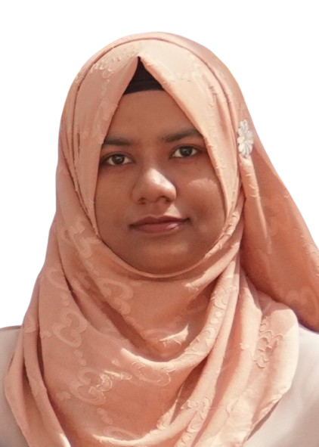
Dola Das is an Assistant Professor in the Department of Computer Science and Engineering at Khulna University of Engineering & Technology (KUET), Khulna, Bangladesh. She received both her B.Sc. Eng. and M.Sc. Eng. in Computer Science and Engineering from KUET. Her research interests include Information Security, Applied Cryptography, and Secure Computing Systems with a focus on privacy-preserving and trustworthy computing. She is open to research collaboration and academic discussions in her areas of expertise. She can be reached at dola.das@cse.kuet.ac.bd.
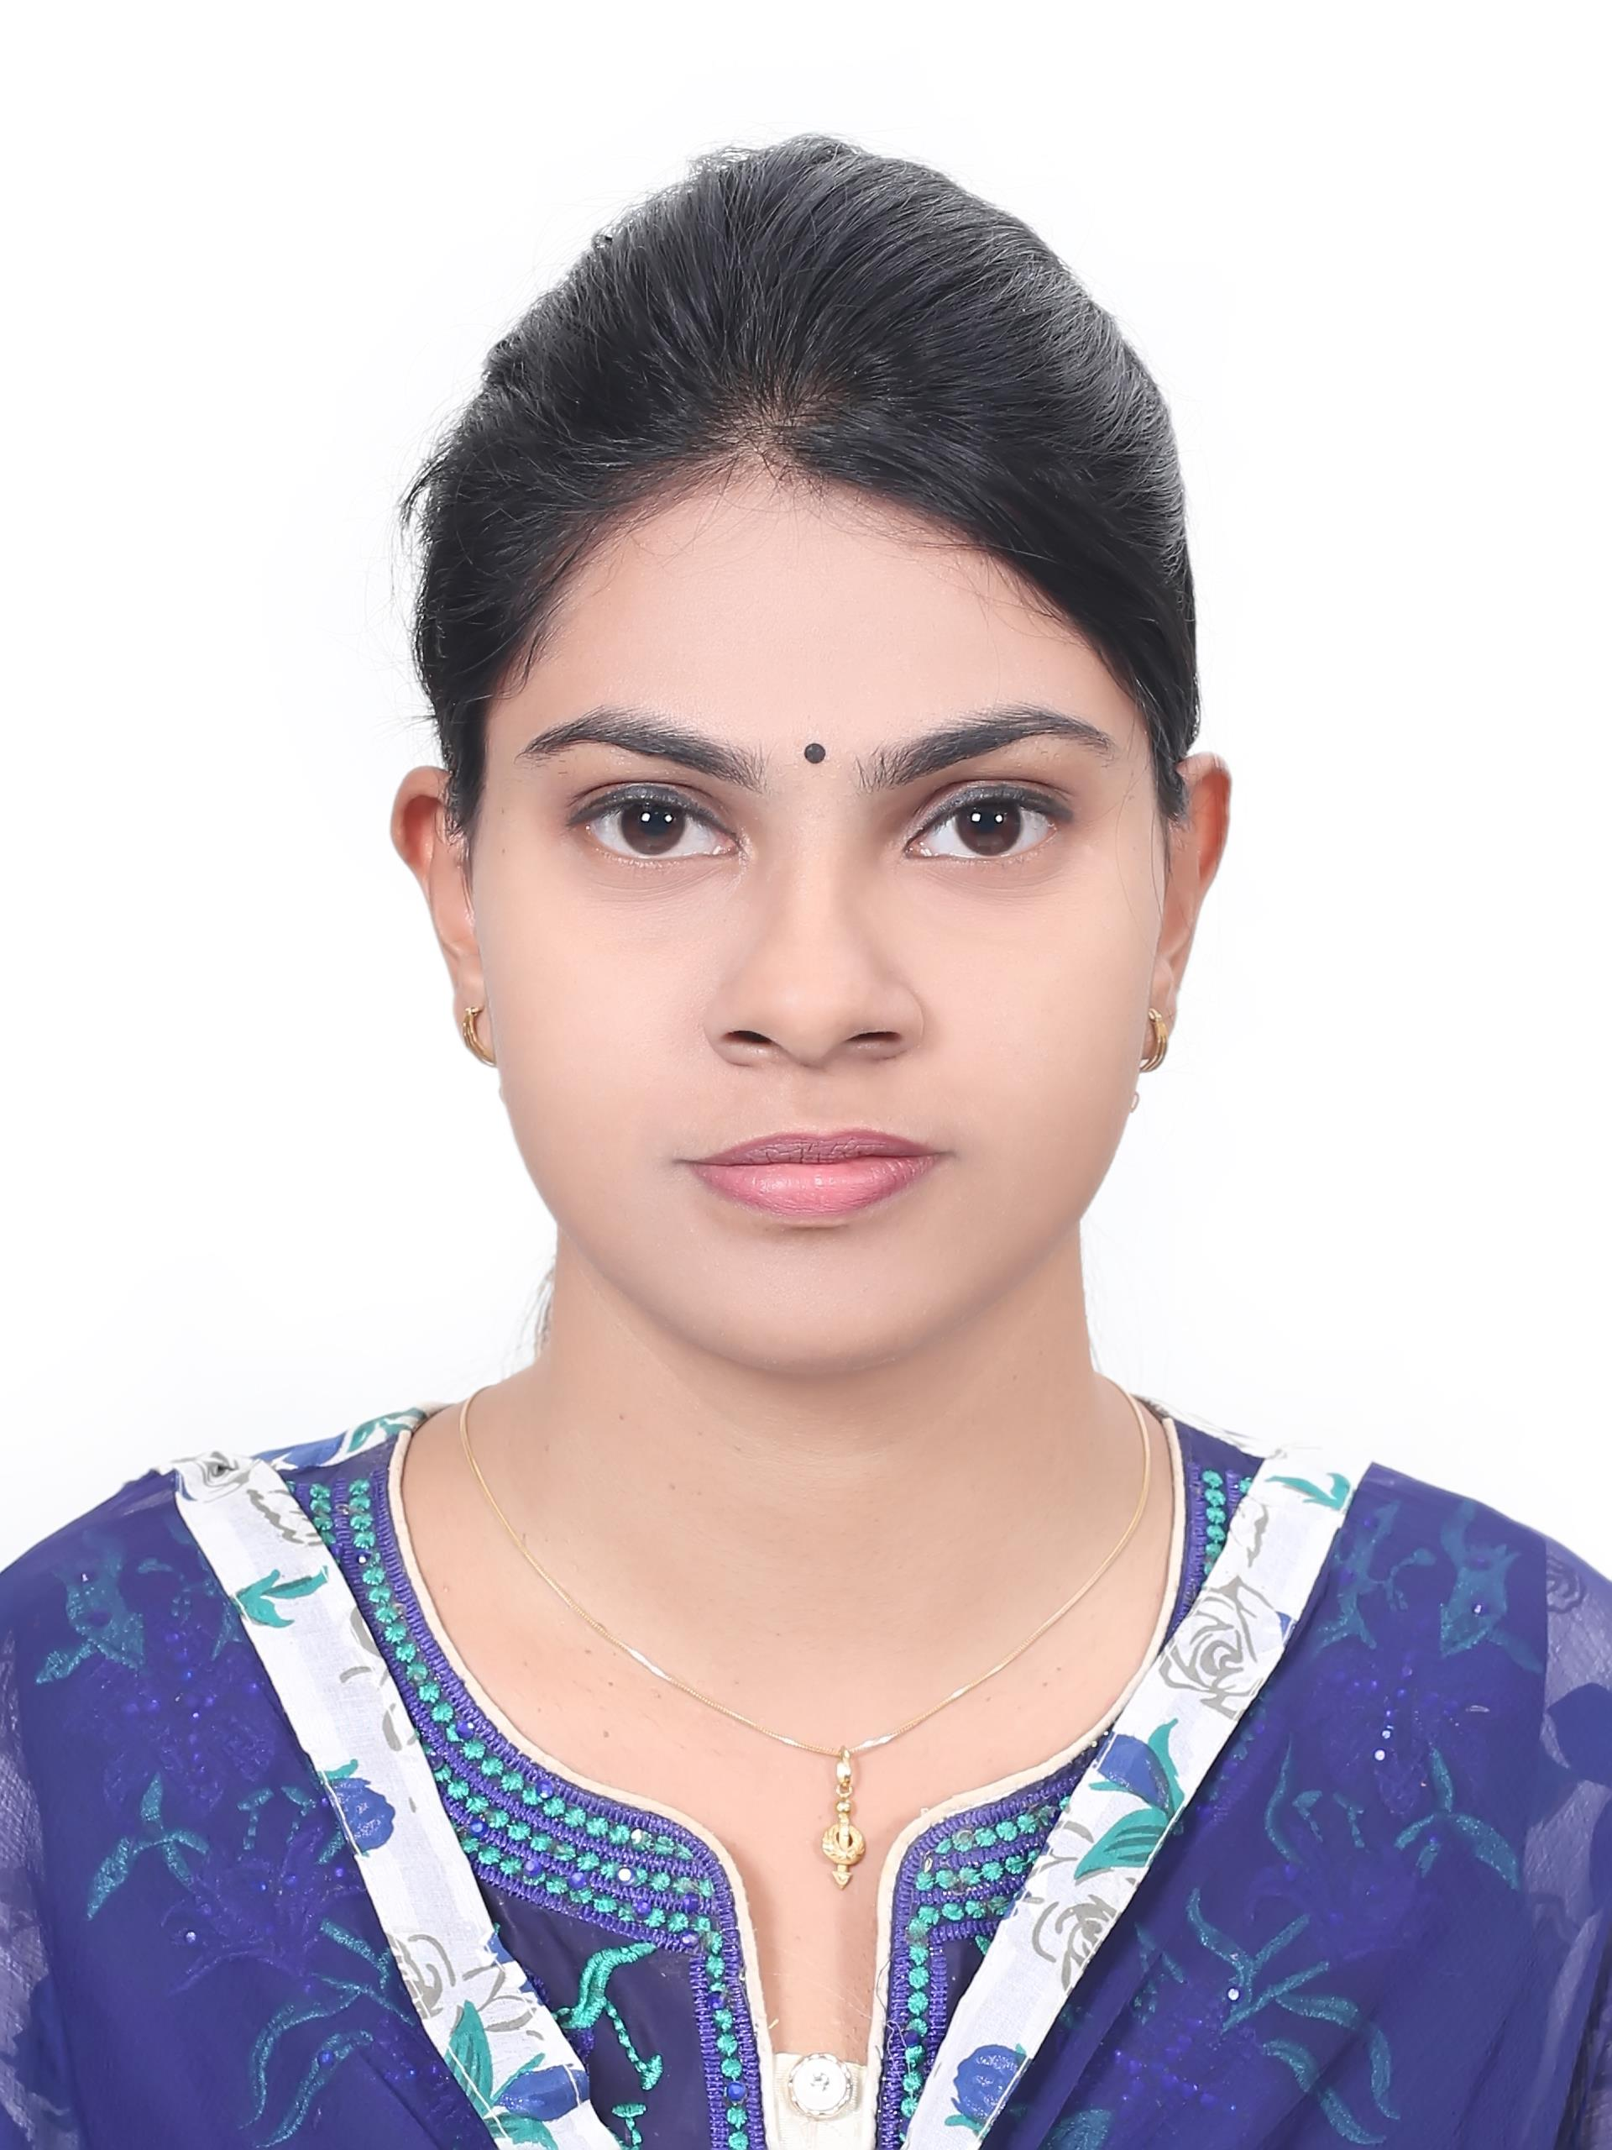
Nusrat Jahan Jonaki received her B.Sc. Eng. in Computer Science and Engineering from Khulna University of Engineering & Technology (KUET), Khulna, Bangladesh. She is currently a Lecturer in the Department of Computer Science and Engineering at Southeast University, Dhaka, Bangladesh. Her research interests include Machine Learning, Artificial Intelligence, Federated Learning, and Cybersecurity. She can be reached at nusratjonaki123@gmail.com
